Insurance Coverage for Autonomous Vehicles: Adapting Insurance Models to New Technology
(10 Keys of Market Transformation)

By: Katherine D. Sheriff

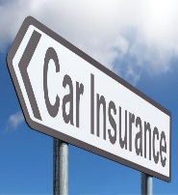

Traditionally, the world of insurance is not one to evolve quickly. Yet, what we have seen is fast-paced development at the intersection of insurance and autonomous vehicles (AVs). Ten leading progress indicators raise key considerations for insurers interested in monitoring the fast-paced convergence of AV technology and the insurance industry.

(1) Integrity of Technology:

How will the automotive industry economics force change in the insurance industry sooner than later?

Why will stock changes occur at a faster rate than typical automotive stock changes every 12 to 13 years?

(2) Capability Accessibility:

What are the anticipated autonomous technology capabilities and dates of introduction for manufacturers?

How will the market adapt to additional autonomous capability in newly-introduced models?

(3) Infrastructure Availability:

Is upfront investment in infrastructure necessary for AV release?

How will Vehicle-to-Infrastructure (V2I) tighten the web of information for a fully integrated driving environment?

(4) Regulatory Permission:

What will happen in 12 states with “no fault” laws with limitations on the right to sue, including Michigan and Florida, with AVs?

How will rate filing requirements for private passenger auto policies work in California for AVs?

(5) Regulatory Findings:

How will the NHTSA interpretation of “driver” under the Federal Motor Vehicle Safety Standards as applicable to one fully autonomous vehicle system impact traditional policies?

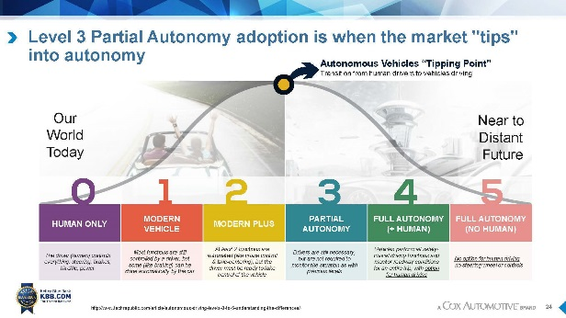

(6) Legal Responsibility:

How do the risks and liabilities associated with autonomous driving vary from those posed by other emerging technologies?

Who should be responsible in an AV collision? Does the level of automation matter? Why?

(7) Consumer Adoption:

If the NHTSA mandates minimum levels of autonomous capabilities, will the price of autonomous features drop and increase consumer use?

Does each driver have a unique value position for AVs or do AVs offer broad appeal that cuts across all demographic sectors?

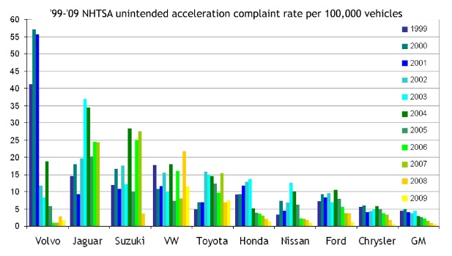

(8) Mobility Services:

Will safer vehicles be accompanied by fewer vehicles operating on roads?

How will ride-sharing services provide transportation at an hourly rate, customer to customer be like Airbnb?

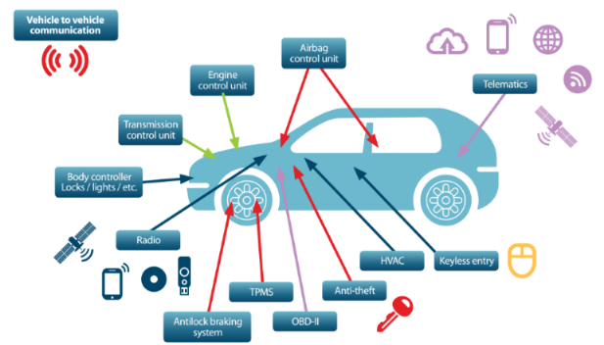

(9) Lobbying Efforts:

How will gradual adoption of AVs include a mix of traditional, semi-autonomous and fully autonomous vehicles?

Should an aftermarket autonomous add-on be required for traditional vehicles?

(10) Data Management:

Will data management encompass more than Big Data management, traditional data security, cybersecurity, and information privacy?

Why is consumer understanding of the difference between various new technologies vital?

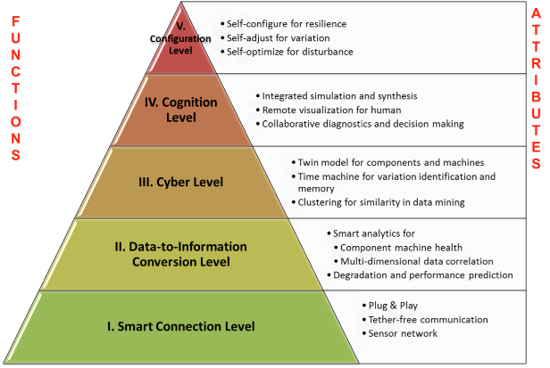

Questions?

We will continue to keep an eye on additional developments in this field. If you would like additional information, please contact me at ksheriff@wachp.com.

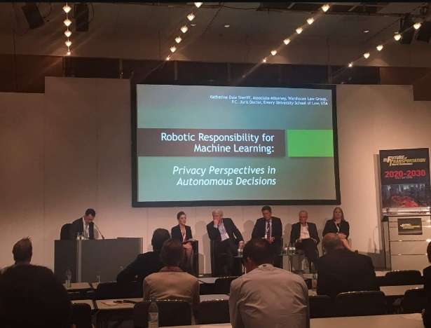

Katherine Sheriff is an associate practicing in the areas of insurance defense and motor vehicle liability. Katherine specializes in autonomous vehicle (AV) liability and began speaking about AV liability in 2014. Katherine testified before the Georgia House Study Committee on Autonomous Vehicle Technology in 2014 and was a featured panelist at the 2016 Autonomous Vehicle Safety Regulation World Congress in Michigan and the 2017 Future of Transportation World Conference in Germany (pictured above). Katherine has been invited to speak at the 2018 Future of Transportation World Conference in Germany. Currently, she is focusing on the role insurers will play in getting AVs to market, cybersecurity and the implications of algorithmic morality in AV decision making on collision liability.

